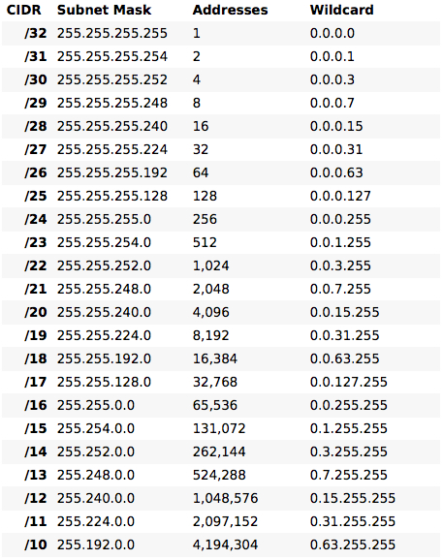

1.Configure Addressing & loopbacks:

Using the addressing scheme in the diagram, apply IP addresses to the Fast Ethernet interfaces on R1, R2, and R3. Create Loopback1 on R1, Loopback2 on R2, and Loopback3 on R3, and address them according to the diagram.

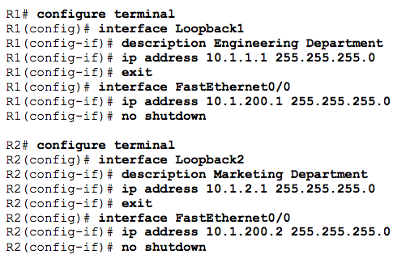

2.Add clock rate:

Configure the serial interfaces on R1 and R2 with the IP addresses shown in the diagram. Add the **clockrate** command where needed.

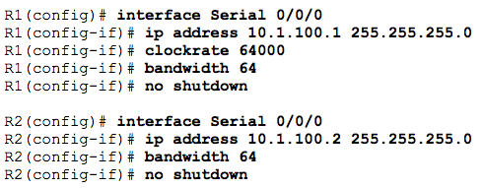

3.Add physical interfaces to OSPF:

Enter the OSPF configuration prompt using the **router ospf** *process_number* command. The process number is a locally significant number that does not affect how OSPF works. For this lab, use process number 1 on all the routers.

Calculate wildcard mask from subnet mask.

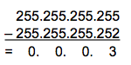

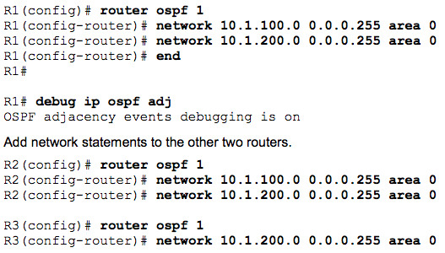

Observe the debug output on R1. When you are finished, turn off debugging on R1 with the **undebug all** command.

3.IP OSPF show Commands:

R1# show ip protocols

The **show ip protocols** command displays basic high-level routing protocol information. The output lists each OSPF process, the router ID, and which networks OSPF is routing for in each area. This information can be useful in debugging routing operations.

R1#show ip ospf

The **show ip ospf** command displays the OSPF process ID and router ID.

R1#show ip ospf neighbor

The **show ip ospf neighbor** command displays important neighbor status, including the adjacency state, address, router ID, and connected interface.

R1#show interface “*type” “number” e.g. #show interface int s0/2*

The **show ip ospf interface** *interface_type number* command shows interface timers and network types.

R1#show ip ospf interface brief

A variation of the previous command is the **show ip ospf interface brief** command, which displays each interface that is participating in the OSPF process on the router, the area it is in, its IP address, cost, state, and number of neighbors.

R1#show ip ospf database

The **show ip ospf database** command displays the various LSAs in the OSPF database, organized by area and type

4.Add loopback interfaces to OSPF:

All three routers have loopback interfaces, but they are not yet advertised in the routing process. You can verify this with the **show ip route** command on the three routers.

#show ip route -to get loopback ip

Before: on R1

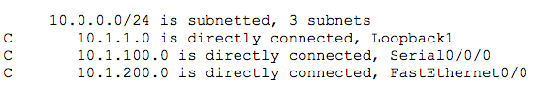

Command:

For each router, the only loopback address displayed is the locally connected one. Add the loopbacks into the routing process for each router using the same **network** command previously used to add the physical interfaces.



Result: on R1

Verify that these networks have been added to the routing table using the **show ip route** command.

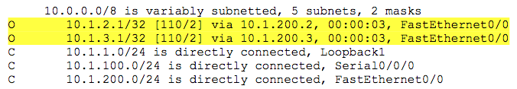

all loopback OSPF network types must be changed to point-to-point



5.TCL script

Use the following Tcl script to verify connectivity to all addresses in the topology.

Rx#tclsh

foreach address{

Ip address

Ip address

Ip address

}{

ping $address}

6.Modify OSPF link costs

When you use the **show ip route** command on R1, you see that the most direct route to the R2 loopback is through its Ethernet connection. Next to this route is a pair in the form [administrative distance / metric ]. The default administrative distance of OSPF on Cisco routers is 110. The metric depends on the link type. OSPF always chooses the route with the lowest metric, which is a sum of all link costs. You can modify a single link cost by using the interface command **ip ospf cost** *cost*. Use this command on both ends of the link. In the following commands, the link cost of the Fast Ethernet connection between the three routers is changed to a cost of 50. Notice the change in the metrics in the routing table.

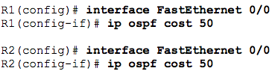

7.Modify interface priorities to control the DR and BDR election.

Use the **ip ospf priority** *number* interface command to change the OSPF priorities on R1 and R2 to make R1 the DR and R2 the BDR. After changing the priority on both interfaces, look at the output of the **show ip ospf neighbor detail** command. You can also see the change with the **show ip ospf neighbor** command, but it requires more interpretation because it comes up with states per neighbor, rather than stating the DR and BDR on a neighbor adjacency network.

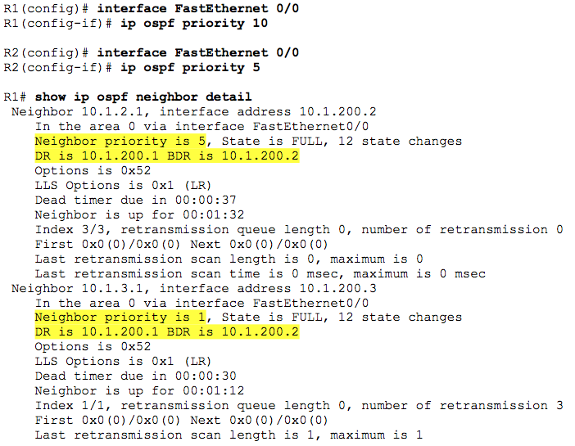

**Note:** To make a router take over as DR, use the **clear ip ospf process** command on all the routers after changing the priorities. Another method of demonstrating the election process and priorities is to shutdown and reactivate all ports on the switch simultaneously. The switch can be configured with **spanning-tree portfast default** and all ports can be shutdown and reactivated using the following commands.

**interface range fa0/1 - 24**

**shutdown**

**no shutdown**

8.Configure a stub area

Under the OSPF process on R2 and R3, make area 23 the stub area using the **area** *area* **stub** command. The adjacency between the two routers might go down during the transition period, but it should come back up afterwards.

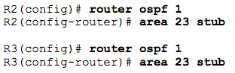

9.Configure a totally stubby area

A modified version of a stubby area is a totally stubby area. A totally stubby area ABR only allows in a single, default route from the backbone. To configure a totally stubby area, you only need to change a command at the ABR, R2 in this scenario. Under the router OSPF process, you will enter the **area 23 stub no-summary** command to replace the existing stub command for area 23. The **no-summary** option tells the router that this area will not receive summary (inter-area) routes.

Enter the **stub no-summary** command on R2 (the ABR) under the OSPF process.



10.Configure a not so stubby area

Not-so-stubby areas (NSSAs) are similar to regular stub areas, except that they allow routes to be redistributed from an ASBR into that area with a special LSA type, which gets converted to a normal external route at the ABR

Change area 23 into an NSSA. NSSAs are not compatible with stub areas, so the first thing to do is issue the **no area 23 stub** command on routers R2 and R3. Next, issue the **area** *area* **nssa** command on routers R2 and R3 to change area 23 to an NSSA. To generate an external route into the NSSA, use the **redistribute connected subnets** command on R3. This adds the previously unreachable loopback 20 into OSPF. Be sure to include the **subnets** keyword; otherwise, only classful networks are redistributed.

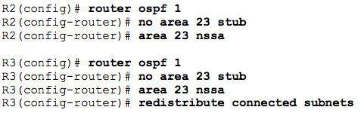

Yet another type of area is a totally-stubby NSSA that combines the property of an NSSA area (injecting external routing information into OSPF) with a totally stubby behavior (accepting only default route from the backbone). Issue the **area 23 nssa no-summary** command on R2, similar to converting a stub area into a totally stubby area.



11.Configure OSPF interface authentication

For security purposes, you can configure OSPF interfaces to use authentication.

Configure the link between R2 and R3 for plaintext authentication. To set up plaintext authentication on an interface, type **ip ospf authentication** at the interface command prompt. Then set the password to **cisco** with the **ip ospf authentication-key** *key-string* command.

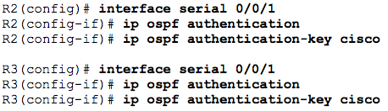

Verify the authentication using the **show ip ospf interface** *interface* command.

MD5 authentication encrypts the password for stronger security. Configure the link between R1 and R2 for MD5 authentication using the **ip ospf authentication message-digest** interface command. Then set the password to **cisco** with the **ip ospf message-digest-key** *key_number* **md5** *key-string* command*.* Make sure that the key number is the same on both routers. In this case, use 1 for simplicity.

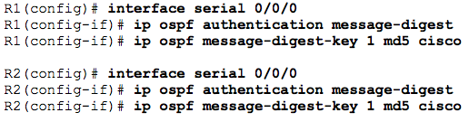

Verify the configuration using the **show ip ospf interface** *interface* command.

12.Create virtual links

If an area is not connected to the backbone, its routes are not advertised outside of its area. You can get around this situation by creating a virtual link. A virtual link is an OSPF feature that creates a logical extension of the backbone area across a regular area, without actually adding any physical interfaces into area 0.

**Note**: Prior to creating a virtual link you need to identify the OSPF router ID for the routers involved (R2 and R3), using a command such as **show ip ospf**, **show ip protocols** or **show ip ospf interface**. The output for the **show ip ospf** command on R1 and R3 is shown below.

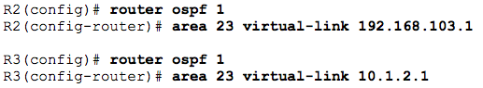

R2# **show ip ospf interface**OSPF_VL0 is up, line protocol is up

Internet Address 10.1.23.2/24, Area 0 Process ID 1, Router ID 10.1.2.1, Network Type VIRTUAL_LINK, Cost: 64

13.Summarize an area

Loopbacks 100 through 103 can be summarized into one supernet of 192.168.100.0 /22. You can configure area 100 to be represented by this single summary route.

a. Configure R3 (the ABR) to summarize this area using the **area** *area* **range** *network mask* command. R3(config)# **router ospf 1**

R3(config-router)# **area 100 range 192.168.100.0 255.255.252.0**

b. You can see the summary route on R2 with the **show ip route** and **show ip ospf database** commands.

R2# **show ip route**

14.Generate a default route into OSPF

You can simulate loopback 30 on R1 to be a connection to the Internet. You do not need to advertise this specific network to the rest of the network. Instead, you can just have a default route for all unknown traffic to go to R1.

To have R1 generate a default route, use the OSPF configuration command **default-information originate always**. The **always** keyword is necessary for generating a default route in this scenario. Without this keyword, a default route is generated only into OSPF if one exists in the routing table. R1(config)# **router ospf 1**

R1(config-router)# **default-information originate always**

Verify that the default route appears on R2 and R3 with the **show ip route** command.

R2# **show ip route**